Please follow the instructions to complete the hands-on. Each instruction expects a command for the Git Bash.

1. Verify if master is in clean state.
2. List out all the available branches.
3. Pull the remote git repository to the master
4. Push the changes, which are pending from **“Git-T03-HOL_002”** to the remote repository.
5. Observe if the changes are reflected in the remote repository.

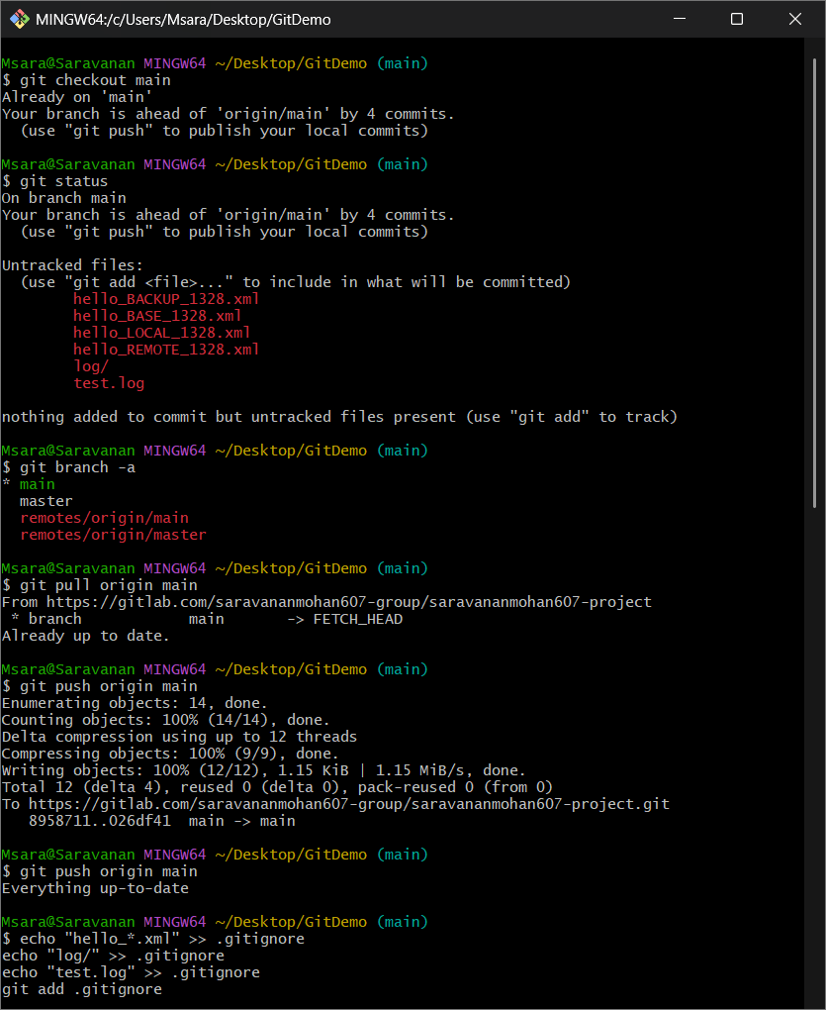

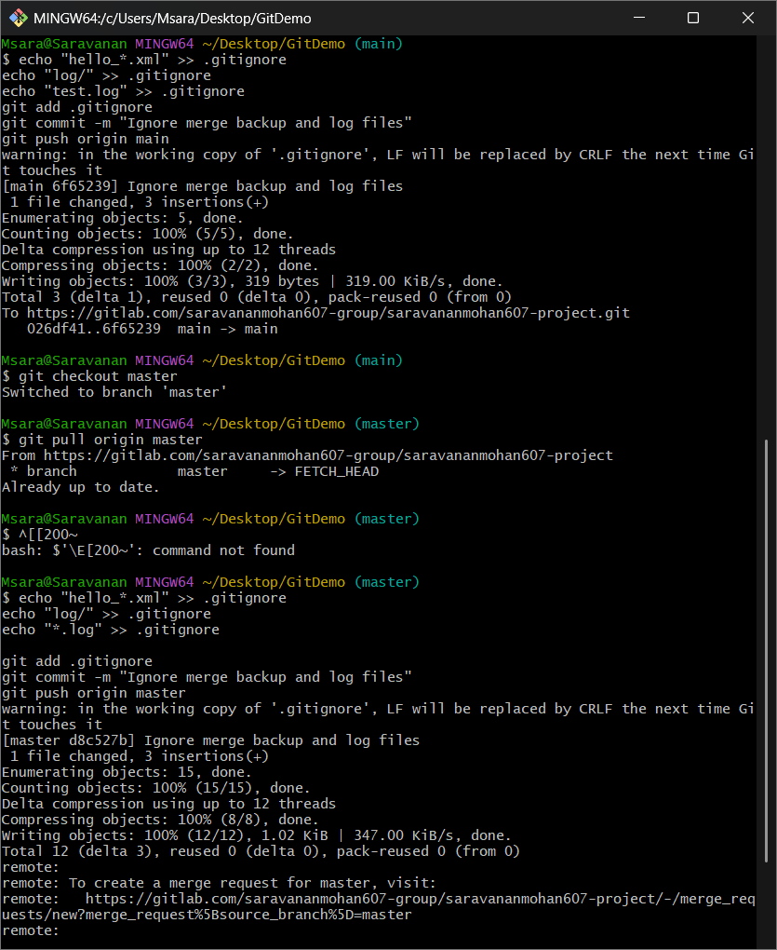

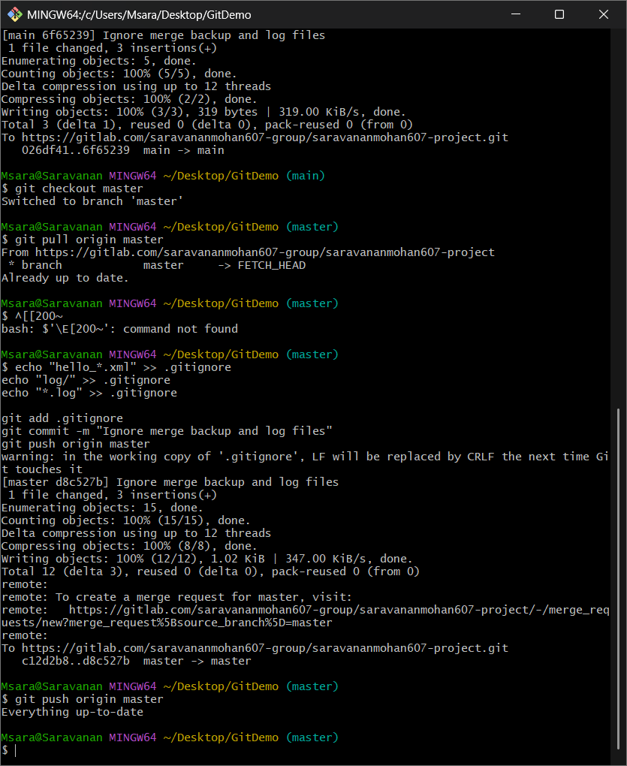

**OUTPUT:**

